**INT – 217 PROJECT REPORT**

***DYNAMIC BUSINESS DASHBROAD***

Submitted by

Akash kumar

Registration No:12106958

Bachelors of Technology

K21DH

Course Code: INT 217

Under the Guidance of

Baljinder Kaur mam **(27952)**

**Discipline of CSE/IT**

**Lovely School of Computer Science and Engineering**

**Lovely Professional University, Phagwara**



**DECLARATION**

I Akash Kumar student of Btech under CSE/IT Discipline at, Lovely Professional University, Punjab, hereby declare that all the information furnished in this project report is based on my own intensive work and is genuine.

Date: 1-11-2023 Signature

Registration No. 12106958 Name of the student Akash kumar

**Acknowledgement**

The opportunity of attaining a project in Excel at Lovely Professional University was worth learning. It was a prestige for me to be part of it.

Pre-eminently, I would like to express my deep gratitude and special thanks to my Baljinder Kaur mam for the theoretical and practical knowledge and encouragement on this project also for the valuable guidance and affection for the successful completion of this project.

I would like thanks Lovely professional University for giving me a opportunity to learn and implement the thing as real project

**Table of Content:**

1. Introduction
2. Objectives/Scope of the Analysis
3. Source of dataset
4. Analysis on dataset
5. Introduction
6. General Description
7. Specific Requirements, functions and formulas
8. Analysis results
9. Visualization
10. List of Analysis with results
11. References
12. Bibliography

Introduction

In today's data-driven world, the ability to transform raw information into actionable insights is a skill highly sought after by professionals across various fields. Microsoft Excel, with its versatile features, offers a powerful platform for achieving this. Excel dashboards, in particular, stand out as a practical way to present complex data in a user-friendly and easily understandable manner.

In this report, we will delve into the world of creating dynamic Excel dashboards. Whether you're a seasoned Excel user or just beginning your data journey, understanding how to craft a dynamic dashboard is an invaluable skill. This article will guide you through the process, from understanding the basics to planning, design, and sharing, ensuring that you can harness the true potential of your data.

So, let's embark on this journey and discover how to create a dynamic Excel dashboard that will empower you to make informed decisions based on your data.

**Objectives/Scope of the Analysis**

* **Key Business Summary :Overall Sales ,Boxes and Profitability looking like**
* **What is happing over the TOP 5 Products with trends either for specific cathegory**
* **What is the Sales Person Performance for each individual Products**

**Source of dataset:**

I have taken data set from the Kaggle website that is already pre-processed having no null values and negative data or an invalid data.

**Analysis on dataset**

**Introduction**

From this dataset, we can learn the following:

The top selling product is the Peanut Butter Cubes, followed by the Fruit & Nut Bars and the Baker's Choco Chips.

The top sales person is Gunnar Cockshoot, followed by Gigi Bohling and Marney O'Breen.

The most expensive product is the Spicy Special Slims, followed by the White Choc and the 99% Dark & Pure.

The most profitable product is the After Nines, followed by the Peanut Butter Cubes and the Baker's Choco Chips.

**General Description**

The variables in the dataset are:

* Sales Person: The name of the sales person.

* Product: The name of the product.

* Date: The date of the sale.

* Sales: The sales amount in dollars.

* Boxes: The number of boxes sold.

* Expenses: The expenses incurred for the sale in dollars.

* Category: The category of the product (Bites, Bars, or Other).

**Distribution:** The distribution of the values in each variable varies. For example, the sales amount ranges from $378 to $16,800.

**Specific Requirements, functions and formulas**

Load the cleaned data into “data model” based pivot tables in Excel. Now, using Power Pivot measures, calculate the necessary KPIs.

For example, for the above business dashboard, I’ve calculated:

* Total Sales =SUM(sales[Sales])
* Total Boxes = SUM(sales[Boxes])
* Total Expenses = SUM(sales[Expenses])
* Total Profit = [Total Sales] – [Total Profit]
* Profit % = [Total Profit] / [Total Sales]

.

**Analysis results**

Now we got our Sample data we can perform our Creating the pivot tables using these measures

**Visualization**

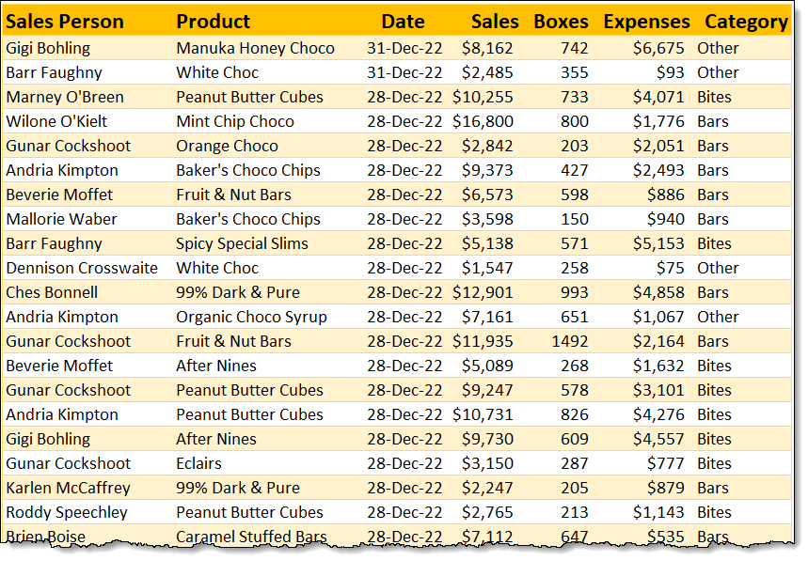

**List of Analysis with results**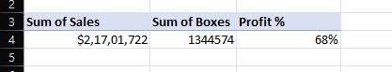

For this first Pivot table we our showing the what is the Total sales ,Boxes and the Total profit in percentage(by Creating the measure)

In the second Pivot table we are showing the Top 5 Product for the dataset

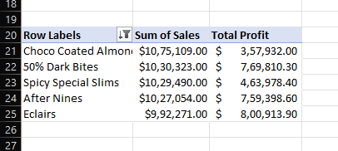

Now to see the trends for the Sales, Boxes and Profit % we now make three more pivot tables showing the month wise Sales , No. of Boxes and the Total profit

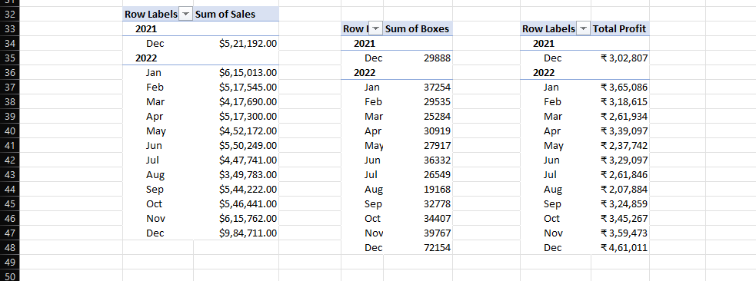

At last we are Creating the pivot table for the sales person report having values as Sales , Expenses , Total profit , Profit %, No. of Boxes

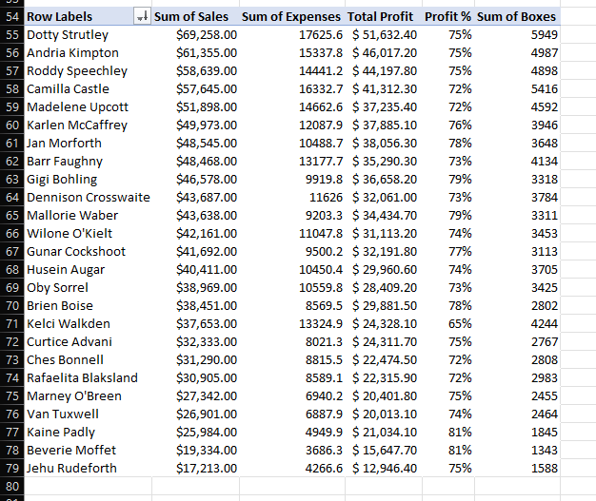

**References**

**https://www.kaggle.com/**

**https://chandoo.org/wp/**

**Bibliography**

This Excel dashboard provides an interactive way to analyze sales data. The dashboard includes charts and tables that visualize the data in different ways, allowing users to identify trends and patterns. The dashboard also includes filters and slicers that allow users to drill down into the data and focus on specific areas of interest.

**Screenshot of the Dashbroad**

